Financial Analysis for Fashion Industry

Kavi Smita Ramya, Johal Navleen, Gupta Shreya, Anvar Maryam, Bhargava Samarth

ISE 200, San José State University, San José, CA

Fashion industry makes a massive amount of revenue each year. It consists of a whopping 7.2% of the total world consumption segment with an immense opportunity for growth and investment. Some of the most notable and sought after brands are Gap Inc., Ralph Lauren, American Eagle Outfitters, Under Armour Inc. and PVH Corp. For a common man, it seems to be a wise choice to compare amongst these brands and invest in the firm with best return on investment. Our objective of this report is to evaluate their ethical grounds and financial strength of each company based on their annual revenue across all the regions and analyze their financial grip on the market by calculating different financial ratios. Among the listed companies, we found GAP Inc. to be the best company based on both their financial strength and ethical grounds.

**Introduction**

Fashion industry is the most glamourous and still an underrated industry in few scenarios. We all wear clothes whether it’s from a famous designer store or ordinary store. Everybody in this world makes his or hers first impression through looks and personality. Each industry must update its product by keeping up to new trends and even by introducing new trends. As per one of the statistics, the global apparel market of United States is expected to grow from USD 225 billion in 2012 to USD 285 billion in 2025.

## American Eagle Outfitters, Inc

American Eagle Outfitters, Inc. (AEO) is built on more than 38 years of customer focus, dedication and innovation. AEO is a chain of mall-based stores that sells casual, outdoor-inspired fashion apparel. Founded by brothers Jerry and Mark Silverman with one store, in Michigan, in 1977. Today, American Eagle has more than 1,000 stores and 40,000 associates worldwide. Built with distinctive global company culture and its core values are – People, Integrity, Passion, Innovation and Teamwork. In June 2009, the company signed the franchise agreement with M. H. Alshaya, one of the leading retailers of the Middle East.

## Ralph Lauren Corporation

Ralph Lauren Corporation is a worldwide leader in the fashion industry, showcasing and distributing premium items in four main categories: apparel, fragrances, accessories, and homes. Over the past few decades, Ralph Lauren reputation and symbolic logo have been reliably ventured across all corners of the globe. Ralph Lauren was originally founded in 1967 by Ralph Lifshitz. Ralph introduced the brand to the world by creating men’s ties. The company brand names, which incorporate Ralph Lauren, Ralph Lauren Collection, Ralph Lauren Purple Label, Double RL, Polo Ralph Lauren, Lauren Ralph Lauren, Polo Ralph Lauren Children, Denim and Supply Ralph Lauren, Chaps, Club Monaco among others, constitute one of the world's most generally perceived groups of buyer brands. Moreover, the company has more than thirteen thousand stores worldwide, including department stores. In addition, based on the statistic, Ralph Lauren has approximately 25,000 employees working globally for them.

## Gap, Inc.

Gap, Inc. is a worldwide apparel retail company.  In July 1969, it was founded by Donald G. Fisher and Doris F. Fisher and is headquartered in San Francisco, CA. Arthur L.Peck has been the company’s Chief Executive Officer and Director since 2005. There are 135,000 full-time employees. Gap Inc. provides accessories, clothing, shoes, and handbags for women, men, and children under the Gap, Banana Republic, Old Navy, Athleta, and Intermix brands. As of March 14, 2017, the company has 3,200 company-operated stores and 450 franchise stores in Asia, Europe, Australia, Latin America, Africa and the Middle East.

## Phillips-Van Heusen Corporation

The PVH Corp, or Phillips-Van Heusen Corporation, is a 8.2 billion USD clothing company in America that sells products through the brands, such as Calvin Klein, Tommy Hilfiger, Van Heusen, IZOD, ARROW, Warner’s, Olga, and Eagle; and licensed brands comprising Speedo, Geoffrey Beene, Kenneth Cole New York, Kenneth Cole Reaction, Sean John, Michael Kors, Michael Kors Collection, and Chaps, as well as various other licensed and private label brands. It has also licensed its own brands over various products. It designs, markets, and retails men’s and women’s apparel and accessories, sportswear, handbags, footwear, golf apparel, fragrances, cosmetics, eyewear, socks, jewelry, watches, outerwear, small leather goods, and furnishings, as well as other related products. The company’s products are distributed at wholesale in department, chain, mass market, specialty, off-price, club, and independent stores; and through company-operated full-price specialty and outlet stores, as well as through e-commerce sites. PVH Corp. was founded in 1881 and is based in New York, New York and has more than 18,800 employees.

## Under Armour Inc.

Under Armour, Inc. is an American company that manufactures footwear, sports and casual apparel including athletic shoes, t-shirts, jackets, hoodies, pants, leggings, shorts and accessories such as bags, gloves, caps and protective gear. Under Armour's global headquarters is in Baltimore, Maryland. Under Armour was founded in 1996 by Kevin Plank, a then 23-year-old former special teams captain of the University of Maryland football team and the Chief Executing Officer. Kevin Plank found that the microfibers used to make shorts were dry for a longer time so he came up with the idea of making t-shirts with the same materials and they today are called the dry fits. Major competitors like Nike and Adidas followed his footsteps. Number of employees is 15,200 and engages in the developing, marketing and distributing of branded performance apparel, footwear and accessories for men, women and youth.

# Financial Statement Analysis

## American Eagle Outfitters

In 2013, due to a “disappointing product execution in the women's category", American Eagle posted only a 3% gain in the 2013 second quarter profits and the stock price dropped drastically. It was then in Jan 2014, when CEO Robert Hanson stepped down and Jay Schottenstein became interim CEO. It was then when, American Eagles announced about closing of 150 stores across the country and 300 more being considered for being shut down because of low profits rooting from fast fashion and e-commerce being on the rise.

## Ralph Lauren

In its 2014 proxy statement, Ralph Lauren said the proposed human-rights risk report would have been an “unnecessary and a potential diversion of corporate resources with no corresponding significant benefit to stockholders.” Ralph Lauren does offer a Citizenship Report, first released in 2013, which includes codes of conduct and ethical guidelines for its suppliers. The report does not detail where the company buys its clothing by country. In 2013, Ralph Lauren Corp., the retailer of its namesake brand clothing, paid about $1.6 million to resolve U.S. regulatory and criminal claims that a subsidiary paid bribe to officials in Argentina from 2005 to 2009. In 2016, and article mentioned how Ralph Lauren sales were affected because of the department closing because the brand made $1.8 billion from the department stores. Furthermore, the most recent backlash the brand received was when Ralph Lauren dressed Melania Trump for inauguration. This would affect the annual sales because how people don’t want to wear their clothing after they saw Melania dressed.

## Gap

In 2012, Al Jazeera covered a report on illegal child labor in Bangladesh employed by major clothing industry players. GAP Inc was one of those covered in this investigation. Gap Inc had denied the allegations thus ending in a final statement by the Al Jazeera as – “complex contracting schemes used by Western retailers can leave them oblivious to abuses committed by agents and subcontractors down the line. However, the “Old Navy” jeans wound up in a finishing house that apparently employs underage girls, it seems to have happened without the awareness or approval of Gap Inc.”

Old Navy opened its first store overseas, after expanding globally in 2012, outside North America in Japan. Old Navy had further expanded its global presence, by opening its first Company-operated stores in China and franchise stores in the Philippines in 2014.

## Phillips-Van Heusen Corporation

PVH Corp to acquire True&Co., a direct-to-consumer intimate apparel e-commerce retailer. PVH is accused of working with suppliers in China who, according to the findings of the report, contribute to the pollution of the Yangtze and Pearl Rivers.

In February 2013, PVH had completed and acquisition of ‘Warnaco’ worth 2.9 billion USD. They believed that the acquisition would be an advantage since the complementary geographic platforms of Warnaco enhanced the opportunities of PVH in the high-growth regions of Asia and Latin America in the Calvin Klein businesses of Jeans and Underwear businesses. In the same year on November 4, the sale of G.H Bass & Co. was successfully completed which allowed PVH to focus their assets on their strategy to drive growth through the higher-margin Calvin Klein and Tommy Hilfiger businesses.

## Under Armour

On January 21,2014 University of Notre Dame and Under Armour started a contract for providing uniforms and athletic equipment for the university. It was the largest of its kind deal which came to effect on July 1,2014. Under Armour purchased MapMyFitness app in February 2015 for $475M. During 2016 Under Armour became Official Match Ball Partner of North American Soccer League. Under Armour and UCLA signed a contract of $280M making it largest show and apparel sponsor in NCAA history during May 2016. During December 2016 Under Armour signed a 10-year agreement with Major League Baseball to become the uniform provider of MLB starting 2020.

In February 2017, CEO of Under Armour Kevin Plank supported President Trump and addressed him as “an asset to the country” and was boycotted by the people for the same. Leading to a #BoycottUnderArmour hashtag on twitter.

# Comparisons of Financial Ratios

## Net Profit Margin

Net Profit Margin means that how a company converts their sales into a profit, generally expressed in percentage. It is the percentage of income remaining after all the costs, taxes, dividends and interest are paid and deducted from the overall revenue of the company.

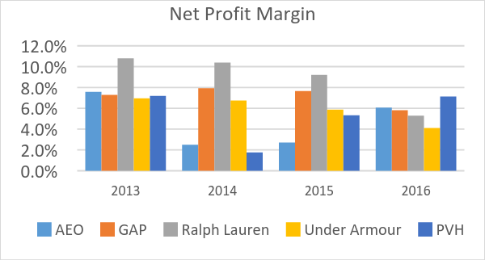

|  |  |  |  |  |
| --- | --- | --- | --- | --- |
| **Net Profit Margin** | | | | |
| **Years** | **2013** | **2014** | **2015** | **2016** |
| **AEO** | 7.6% | 2.5% | 2.7% | 6.1% |
| **GAP** | 7.3% | 7.9% | 7.7% | 5.8% |
| **Ralph Lauren** | 10.8% | 10.4% | 9.2% | 5.3% |
| **Under Armour** | 7.0% | 6.8% | 5.9% | 4.1% |
| **PVH** | 7.2% | 1.8% | 5.3% | 7.1% |

**Table 1 Figure 1**

Higher the net profit margin the better is the financial strength of the company. Below are the following observations of the collected data:

* Ralph Lauren and Under Armour has a very consistent decrease in the net profit margin
* Net profit margin of American Eagle Outfitters went way too down in 2014 and 2015, but they gained approximately 3.4% from 2015 to 2016
* GAP had a consistent performance from 2013-2015, but their net profit margin fell by 1.9%
* As for PVH their net profit margin had its ups and downs. Even though out of all the five companies PVH had the highest Net profit margin in 2016, we can’t completely trust the company just based on this ratio.

From the above evaluation, we can say that GAP has acceptable Net Profit Margin followed by PVH.

## Sales Growth

Sales growth is the increase in sales over a period, usually represented in percentage. The sales growth data provide a breakdown to show how the organization is performing. The main key terms used are the Current sale revenue and previous sales revenue. It is a way of stating how much the company has grown over a period.

|  |  |  |  |  |  |
| --- | --- | --- | --- | --- | --- |
| **Sales Growth** | | | | | |
| **Years** | **2013** | | **2014** | **2015** | **2016** |
| **AEO** | 11.54% | -4.89% | | -0.91% | 7.32% |
| **GAP** | 7.57% | 3.19% | | 1.80% | -3.89% |
| **Ralph Lauren** | 1.17% | 7.35% | | 2.28% | -2.76% |
| **Under Armour** | 27.32% | 32.19% | | 28.57% | 21.97% |
| **PVH** | 2.5% | 35.60% | | 0.61% | -2.67% |

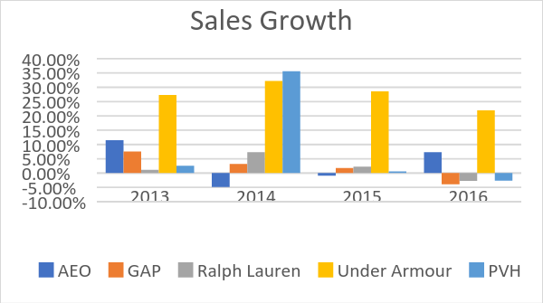

**Table 2 Figure 2**

After comparing the sales growth for all the five companies, following conclusions can be made:

* Ralph Lauren, GAP & PVH has consistent drop in their individual sales growth
* AEO, sales growth is not consistent and has its ups and downs.
* From all the five selected companies Under Armour has the best ratio/percentage. They have few variations in their sales growth throughout the four years.

Hence, we can conclude that Under Armour has an excellent sales growth.

**Earnings Per Share**

Earnings Per Share(EPS) is the amount reserved from the profit of the company that is allocated to each outstanding share of the common stock. Higher the earning per share higher the profits for the company i.e. it serves as an indicator for the profits made by the companies. Two companies can have the same EPS number but the company getting the EPS number by investing less is the better of the two and will be more efficient.

|  |  |  |  |  |
| --- | --- | --- | --- | --- |
| **Earnings Per Share (EPS)** | | | | |
| **Years** | **2013** | **2014** | **2015** | **2016** |
| AEO | 1.35 | 0.43 | 0.46 | 1.10 |
| GAP | 2.37 | 2.78 | 2.90 | 2.24 |
| Ralph Lauren | 8.21 | 8.56 | 7.96 | 4.65 |
| Under Armor | 0.77 | 0.98 | 1.08 | 0.45 |
| PVH | 5.98 | 1.77 | 5.33 | 6.95 |

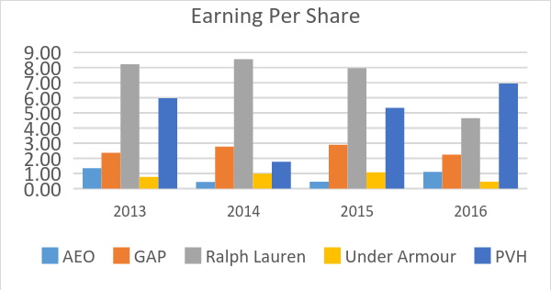

**Table 3 Figure 3**

Following conclusions can be made from the above calculations,

* Ralph Lauren and Under Armour have a decreasing trend in Earnings per share which is the most looked out indicator on the Wall Street in terms of a company’s profitability.
* EPS ratio for AEO is not consistent and has its ups and downs.
* GAP has almost a steady EPS ratio over 4 years.
* PVH has an improved EPS ratio in the last two years.

Hence, we can conclude PVH has acceptable Earnings Per Share (EPS) ratio.

## Return on Investments

Return on Investments (ROI) is the measure of the profit or the loss from an investment. This ratio is used to compare the company’s profitability or to compare between two investments which is better.

|  |  |  |  |  |
| --- | --- | --- | --- | --- |
| **Return on Investments** | | | | |
| **Years** | **2013** | **2014** | **2015** | **2016** |
| **AEO** | 0.216 | 0.071 | 0.078 | 0.203 |
| **GAP** | 0.22 | 0.24 | 0.23 | 0.19 |
| **Ralph Lauren** | 0.18 | 0.15 | 0.14 | 0.08 |
| **Under Armor** | 0.14 | 0.12 | 0.10 | 0.07 |
| **PVH** | 0.07 | 0.01 | 0.05 | 0.06 |

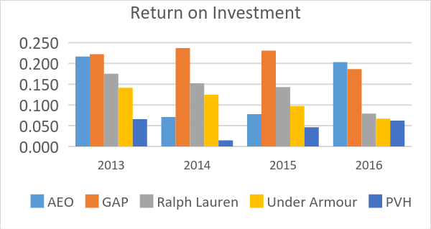

**Table 4** **Figure 4**

The better the ratio the better is the return on investments for the company. The following are the results based on our observation for the five companies,

* Ralph Lauren and Under Armour have low ratios and have a decreasing trend implying lesser returns on the cost of investments.
* PVH has a consistently low return on investment.
* Whereas AEO and GAP have better ratios, but GAP has almost uniform returns on their investments.

Hence, we can conclude that GAP has the best Return on Investments ratio.

## Return on Equity

Return on Equity(ROE) is the ratio of the net income to the shareholder’s equity i.e. the profit made on each dollar of the shareholder’s equity. Also, called as the ‘return on net worth’. Increase in the total return of equity means that the company has an increasing profit over time without much change in the initial capital investments. It is used to calculate the efficiency for the company more than the profits for the company as the value for ROE can co up even if the value for the shareholder’s equity goes down.

|  |  |  |  |  |
| --- | --- | --- | --- | --- |
| **Return on Equity** | | | | |
| **Years** | **2013** | **2014** | **2015** | **2016** |
| **AEO** | 0.216 | 0.071 | 0.078 | 0.203 |
| **GAP** | 0.394 | 0.418 | 0.423 | 0.361 |
| **Ralph Lauren** | 0.198 | 0.193 | 0.180 | 0.106 |
| **Under Armor** | 0.154 | 0.154 | 0.139 | 0.098 |
| **PVH** | 0.134 | 0.033 | 0.101 | 0.126 |

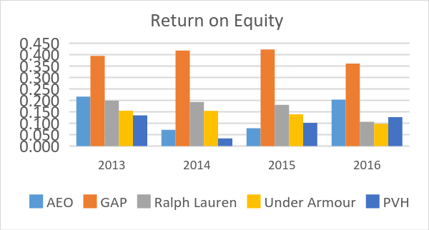

**Table 5 Figure 5**

Hence, higher the ratio better the efficiency of the company. After comparing the Return on equity ratio of all the five companies, we can infer that

* Under Armour has the lowest ROE ratio
* Ralph Lauren and PVH has an average ratio of 0.1, which is low.
* GAP has the highest return per dollar of shareholder’s equity.
* AEO has the next best ROE however, during the years 2014 and 2015, they have a dip in the overall performance of the company.

Hence, we can infer that GAP has the best Return on Equity.

## Current Ratio

Current ratio is the ratio of current assets to current liability.

|  |  |  |  |  |
| --- | --- | --- | --- | --- |
| **Current Ratio** | | | | |
| **Years** | **2013** | **2014** | **2015** | **2016** |
| **AEO** | 2.610 | 2.223 | 1.940 | 1.560 |
| **GAP** | 1.765 | 1.808 | 1.937 | 1.571 |
| **Ralph Lauren** | 2.634 | 3.423 | 2.790 | 2.542 |
| **Under Armor** | 2.649 | 3.676 | 3.133 | 2.858 |
| **PVH** | 2.103 | 1.935 | 2.028 | 1.837 |

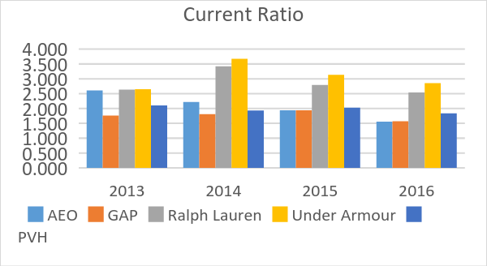

**Table 6**

A ratio of greater than 1 is a safe margin, whereas anything greater than 2 is considered as a poor cash management. After comparing the current ratio of all the five companies, we can infer that -

* Ralph Lauren and Under Armour has a current ratio of more than 2, hence we can infer that they inefficient cash management systems.
* PVH has an unpredictable current ratio over past 4 years.
* Even though American Eagle Outfitters had a ratio of more than 2 from 2013-2014, but they have a consistently improving current ratio over the last 4 years.
* GAP has a ratio less than 2 consistently over 4 years.

Hence, we can infer that GAP has an excellent Current Ratio.

## Stock Price

The price of a company's shares is often used as an indication of the overall strength and health of a company. In general, if a company's share price has continued to climb over time, the company and its management are considered to be doing a good job. Constant growth in the stock prices, makes the employees/ management feel a sense of job security and investors can expect better returns every year.

|  |  |  |  |  |
| --- | --- | --- | --- | --- |
| **Stock Price** | | | | |
| Years | 2013 | 2014 | 2015 | 2016 |
| AEO | 20.52 | 14.76 | 13.94 | 15.3 |
| GAP | 31.57 | 39.09 | 42.37 | 24.12 |
| Ralph Lauren | 152.75 | 174.44 | 185.98 | 91.27 |
| Under Armour | 12.4 | 22.61 | 35.85 | 42.7 |
| PVH | 113.3 | 135.76 | 128.89 | 72.72 |

**Table 7 Figure 7**

The following are the results based on our observation for the five companies,

* AEO has a constant drop in their stock price over the past four years
* PVH, Ralph Lauren and GAP had approximately a constant growth in their stock price, but in 2016 all the three companies shares dropped.
* Even though Under Armour share prices is not as high as compared to Ralph Lauren and PVH, but their stock price has a steady growth over the past four years.

Hence, we can infer that Under Armour has an acceptable stock price over past four years.

Conclusion

We prepared a performance matrix of all the five companies based on our financial ratio calculations. From our evaluation, we inferred that GAP Inc. had best ratios for most of the calculations. Even though their sales growth is decreasing every year, there net profit margin, return on investments, return on equity and current ratio is much better than the other companies. Gap as a company has taken initiatives for a better environment by reducing its carbon footprint to decrease the pollution.

From our calculations, Ralph Lauren has the lowest ratio after Under Armour.

|  |  |  |  |  |  |
| --- | --- | --- | --- | --- | --- |
| **Performance Matrix** | | | | | |
| **Measure** | **AEO** | **GAP** | **Ralph Lauren** | **Under Armour** | **PVH** |
| **Net Profit Margin** | Low | **High** | Low | Low | Moderate |
| **Sales Growth** | Moderate | Low | Low | **High** | Low |
| **Earnings per share** | Low | Moderate | Low | Low | **High** |
| **Return on Investments** | Moderate | **High** | Low | Low | Low |
| **Return on Equity** | Moderate | **High** | Low | Low | Low |
| **Current Ratio** | Moderate | **High** | Low | Low | Moderate |
| **Stock Price** | Low | Moderate | Moderate | **High** | Moderate |

**Table 8**

References:

1. Marketwatch.com
2. Morningstar.com
3. Gap.com
4. [underarmour.com](http://www.underarmour.com)
5. ae.com
6. ralphlauren.com
7. pvh.com
8. finance.yahoo.com
9. statista.com

Ralph Lauren Corp. Cl A. (n.d.). Retrieved May 16, 2017, from <http://www.marketwatch.com/investing/stock/rl/financials>

Bourne, L. (2017, January 20). Ralph Lauren Is Already Receiving Major Backlash for Dressing Melania Trump. Retrieved May 16, 2017, from http://www.glamour.com/story/ralph-lauren-receiving-backlash-for-dressing-melania-trump

Wahba, P. (2016, June 08). Macy's problems are taking a massive toll on Ralph Lauren. Retrieved May 16, 2017, from http://fortune.com/2016/06/08/ralph-lauren-macys/

Ralph Lauren: Shop Clothing for Men, Women, Children & Babies. (n.d.). Retrieved May 16, 2017, from http://www.ralphlauren.com/